Program 6

Write a python code to check that the number is positive or not?

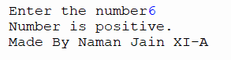

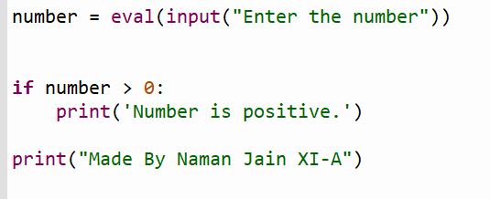

Program 7

Write a python code to classify the age of user?

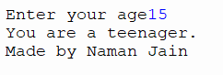

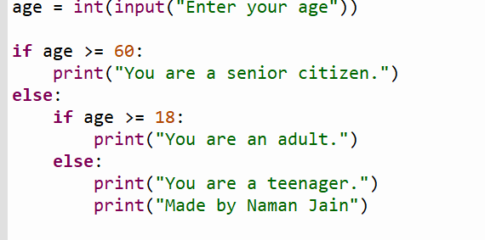

Program 8

Write a Python code to check whether you are Passed or Failed?

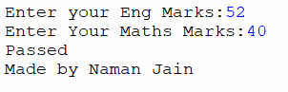

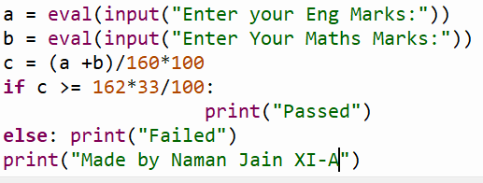

Program 9

Write a python code to display first N Natural number?

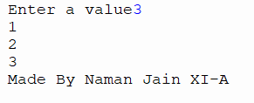

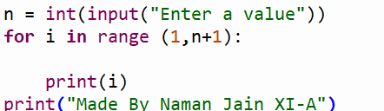

Program 10

Write a python code to make a loop of a alphabet multiple times?

